***Environmental monitoring in parks***

*IoT (Internet of Things)-based environmental monitoring in parks leverages sensor technologies and network connectivity to collect real-time data on various environmental parameters. Here's how it can be implementd:*

1. ***Sensor Deployment:*** *Install IoT sensors strategically throughout the park to monitor different environmental factors. These sensors can include weather stations, water quality sensors, air quality sensors, and wildlife tracking devices.*
2. ***Data Collection:*** *The sensors continuously collect data on parameters such as temperature, humidity, air quality (including pollutants like CO2, NO2, and particulate matter), water quality (pH, turbidity, dissolved oxygen), and wildlife movement.*
3. ***Wireless Connectivity:*** *IoT devices use wireless communication technologies like Wi-Fi, LoRa, or cellular networks to transmit data to a central server or cloud-based platform.*
4. ***Data Storage:*** *The data is stored in a cloud-based database, making it accessible from anywhere. It can be securely archived for historical analysis.*
5. ***Real-time Monitoring:*** *Park authorities can access real-time data through web-based dashboards and mobile apps. This allows for immediate responses to any emerging environmental issues or hazards.*
6. ***Alerts and Notifications:*** *Implement alert systems that trigger notifications when specific environmental thresholds are breached. For example, if air quality deteriorates beyond a certain level, an alert is sent to park management for action.*
7. ***Data Analysis:*** *Historical data can be analyzed to identify trends, seasonal patterns, or long-term changes. This information can inform decision-making and conservation efforts.*
8. ***Visitor Engagement:*** *Some parks provide real-time environmental data to park visitors through kiosks, mobile apps, or websites, creating awareness and educating the public about the park's ecology.*
9. ***Energy Efficiency:*** *IoT sensors can be powered by renewable energy sources, such as solar panels, to reduce the environmental impact of monitoring systems.*
10. ***Cost Savings:*** *By providing real-time data and early warning of environmental issues, IoT-based monitoring can help park authorities make cost-effective decisions and reduce operational expenses.*
11. ***Wildlife Conservation:*** *IoT sensors can be used for wildlife tracking and research. For example, GPS collars on animals can provide data on their movements and behaviors.*
12. ***Research Collaboration:*** *Data collected through IoT can be shared with researchers and environmental organizations, contributing to broader conservation efforts.*

***Python program for connecting mobile app with environmental monitoring in parks IOT project:***

*Import time*

*Import random*

*# Simulated environmental data collection*

*Def collect_environmental_data():*

*Temperature = random.uniform(10, 30)*

*Humidity = random.uniform(20, 80)*

*Air_quality = random.randint(1, 100)*

*Return temperature, humidity, air_quality*

*# Data processing and analysis*

*Def analyze_environmental_data(data):*

*Temperature, humidity, air_quality = data*

*# Perform analysis or set thresholds for alerts*

*If temperature > 25:*

*Print(“High temperature alert!”)*

*If air_quality > 70:*

*Print(“Poor air quality alert!”)*

*# Main monitoring loop*

*While True:*

*Environmental_data = collect_environmental_data()*

*Analyze_environmental_data(environmental_data)*

*Time.sleep(3600) # Simulate data collection every hour*

*To connect a mobile app with environmental monitoring systems in parks, you'll need to establish communication between the app and the monitoring infrastructure. Here are the steps involved in connecting a mobile app to an environmental monitoring system in parks:*

1. ***Define App Objectives and Features:***
   * *Clearly define the goals of the mobile app and the features it should offer, such as real-time data visualization, alert notifications, historical data access, and user engagement elements.*
2. ***IoT Sensor Deployment:***
   * *Ensure that IoT sensors are strategically deployed throughout the park to collect environmental data. These sensors should transmit data to a central server or cloud platform.*
3. ***Cloud-Based Data Management:***
   * *Implement a cloud-based platform to store and manage the data collected by IoT sensors. Services like AWS IoT, Azure IoT, or Google Cloud IoT can be used for this purpose.*
4. ***API Development:***
   * *Create APIs that enable communication between the mobile app and the cloud-based IoT platform. These APIs should allow the app to retrieve real-time and historical environmental data.*
5. ***Mobile App Development:***
   * *Develop the mobile app for both iOS and Android platforms. Consider using a cross-platform framework like React Native, Flutter, or Xamarin to streamline development*

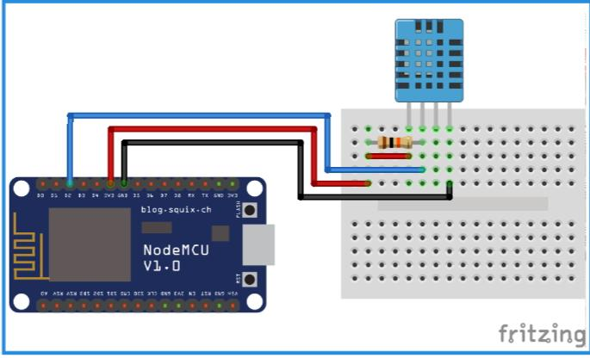***CIRCUIT DIAGRAM FOR ENVIRONMENTAL MONITORING IN PARKS:***